INTRODUCTION:
The particle density of a soil measures the mass in a given volume of particles. Particle density focuses on just the soil particles themselves and not the volume they occupy in the soil. Bulk density includes both the volume of the solid (mineral and organic) portion of the soil and the spaces where air and water are found.
Density is measured as mass per unit volume (mass divided by volume). Soil particle density depends on the chemical composition and structure of the minerals in the soil. Most mineral particles in soils have a particle density ranging from 2.60 to 2.75 g/cm3. However, the density can be as high as 3.0 g/cm3 for very dense mineral particles, and as low as 0.9 g/cm3 for organic particles.
Particle density is important to determine because it allows us to understand many other properties of the soil. For example, knowing the particle density allows us to know something about the relative amount of organic matter vs. mineral particles in the soil sample. Because particle density can be compared to the density of known minerals such as quartz, feldspar, and micas, or denser minerals such as magnetite, garnet, or zircon, this measurement also helps to indicate the chemical composition and structure of the soil minerals.
If we have information on both the particle density and the bulk density of the soil, we can calculate the pore space (or porosity) that is occupied by air and water. This is useful because it helps us to understand other important soil properties such as how much water can be stored in the soil, how fast water and heat will be moved through the soil, how easily roots can move through the soil, and the potential for flooding or drought in an area.
OBJECTIVE:
To determine the field or in-situ density or unit weight of soil by core cutter method
THEORY:
Field density is defined as weight of unit volume of soil present in site. That is
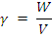
Where, Density of soil
W = Total weight of soil
V = Total volume of soil

The soil weight consists of three phase system that is solids, water and air. The voids may be filled up with both water and air, or only with air, or only with water. Consequently the soil may be dry, saturated or partially saturated.
In soils, mass of air is considered to be negligible, and therefore the saturated density is maximum, dry density is minimum and wet density is in between the two.
Dry density of the soil is calculated by using equation,
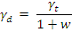
Where, dry density of soil
Wet density of soil
w = moisture content of soil.

Density or unit weight of soils may be determined by using the following method:
- Core cutter method
- Sand replacement test
- Rubber balloon test
- Water displacement method
- Gamma ray method

Hear we use core cutter method, the equipment arrangement is shown as fallows,
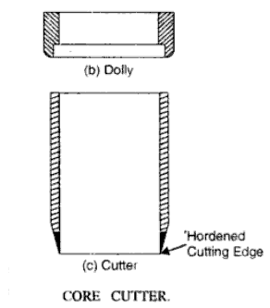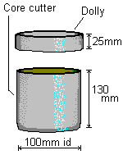
APPRATURS REQUIRED:-
- Special:
- Cylindrical core cutter
- Steel rammer
- Steel dolly
- General:
- Balance of capacity5 Kg and sensitivity 1 gm.
- Balance of capacity 200gms and sensitivity 0.01 gms.
- Scale
- Spade or pickaxe or crowbar
- Trimming Knife
- Oven
- Water content containers
- Desiccator.

APPLICATION:
Field density is used in calculating the stress in the soil due to its overburden pressure it is needed in estimating the bearing capacity of soil foundation system, settlement of footing earth pressures behind the retaining walls and embankments. Stability of natural slopes, dams, embankments and cuts is checked with the help of density of those soils. It is the density that controls the field compaction of soils. Permeability of soils depends upon its density. Relative density of cohesionless soils is determined by knowing the dry density of soil in natural, loosest and densest states. Void ratio, porosity and degree of saturation need the help of density of soil.
Core cutter method in particular, is suitable for soft to medium cohesive soils, in which the cutter can be driven. It is not possible to drive the cutter into hard, boulder or murrumy soils. In such case other methods are adopted.

FIGURES:-
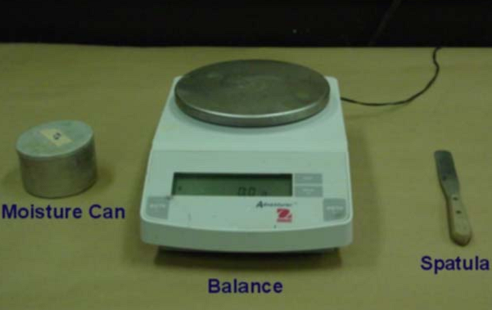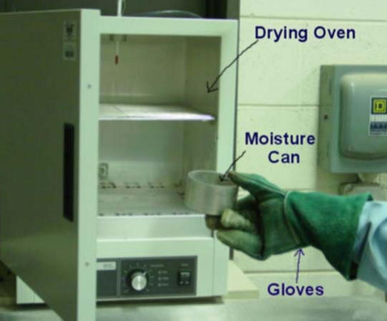

TEST PROCEDURE:-
- Measure the height and internal diameter of the core cutter.
- Weight the clean core cutter.
- Clean and level the ground where the density is to be determined.
- Press the cylindrical cutter into the soil to its full depth with the help of steel rammer.
- Remove the soil around the cutter by spade.
- Lift up the cutter.
- Trim the top and bottom surfaces of the sample carefully.
- Clean the outside surface of the cutter.
- Weight the core cutter with the soil.
- Remove the soil core from the cutter and take the representative sample in the water content containers to determine the moisture content
PRECAUTIONS:
- Steel dolly should be placed on the top of the cutter before ramming it down into the ground.
- Core cutter should not be used for gravels, boulders or any hard ground.
- Before removing the cutter, soil should be removed around the cutter to minimize the disturbances.
- While lifting the cutter, no soil should drop down

Water/Moisture content determination:
 | sample 1 | sample 2 | sample 3
Weight of can, W₁ (g)
Weight of can + wet soil W₂ (g)
Weight of can + dry soil W₃ (g)
Water/Moisture content
Calculation Table:
 | sample 1 | sample 2 | sample 3
Mass of core cutter, W₁ (gm)
Mass of cutter + soil from field, W₂ (gm)
Wet density, (gm/cm3)
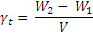
Dry density , (gm/cm3)
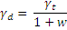

REFERENCES:-
- IS : 2720 (Part II) – 1973, Method of Test for soil : Part II
- Soil Mechanics and Foundations.
- http://www.sciencedirect.com
- http://home.iitk.ac.in/~madhav/
- Geotechnical Laboratory of DGM, Thimphu Bhutan

QUIZ:
- Out of wet density, dry density, and saturated density, which one of them is maximum and minimum? Explain.
- What are the main factors which affect in-situ density of soil? Explain.
- Beside the density what other properties do you need to calculate the void ratio and degree of saturation of soils?
- What are the other methods to calculate the field density of soil?
- What is the value of density of organic clay?
a) about 0.9 g/cm³ b) 0.1 g/cm³ c) 3 g/cm³ d)none
- What is the value of density of pure water?
a) 1 g/cm³ b) 0.1 g/cm³ c) 10 g/cm³ d) 9.81 g/cm³
- Density of soil changes with?
a) void ratio b) water content c) permeability d) a & b
- Density of soil changes with depth of soil?
a) True b) False c) may be d) none

Objective:
- Dry density of soil can be defined as the ratio of
- Weight of solids to total volume
- Weight of soil to the total volume of solids
- Unit weight of the soil to the unit weight of water
- None
- The bulk density of coarse grained soils can be determined by
- Sand replacement method
- Core cutter method
- Pycnometer method
- Torsion balance method
- The bulk density of clays can be determined by
- Core cutter method
- Pycnometer method
- Torsion balance method
- Sand replacement method
- Fundamental relationship between dry density(),bulk density(), and water content() is
- (______________________)
- The submerged density of soil in terms of unit weight of water , specific gravity G and void ratio e is given by the expression
- (__________________)
- Choose the correct one
- >>>
- ><>
- ===
- <<<
- Unit weight of solids depends on
- Compaction
- Consolidation
- Specific gravity
- Void ratio
- Bulk density, saturation density and dry density of soil varies upon
- Degree of compaction
- Degree of consolidation
- Water content
- Porosity
- Different soils have different unit weights
- True
- False
- Cannot be answered
- Could not be answered
- Select the correct one
- Unit weight of dry soil is greater than unit weight of wet soil
- For dry soils, dry unit weight is less than total unit weight
- Unit weight of soil increases due to submergence in water
- Unit weight of soil decreases due to submergence in water

PART – 2
ANIMATION STEPS

It consists of step wise animation.

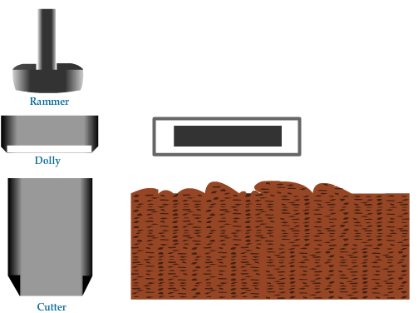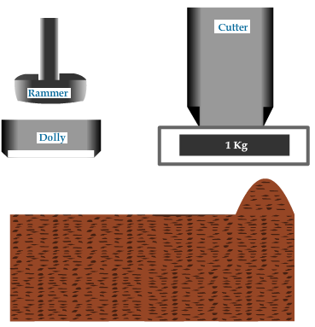
STEP – 1 STEP – 2
Step – 1: Apparatus with unleveled soil.
Step – 2: Weight of empty cutter and soil is leveled.

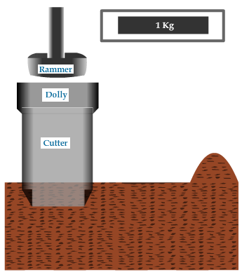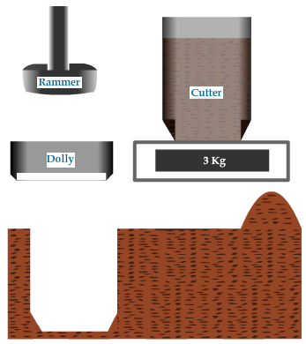
STEP – 3 STEP – 4
Step – 3: Dolly is placed on Cutter and beaten with the help of Rammer in to the
soil.
Step – 4: Weight of undisturbed sample soil and with Cutter.

PART – 3
VIRTUAL LAB FRAME
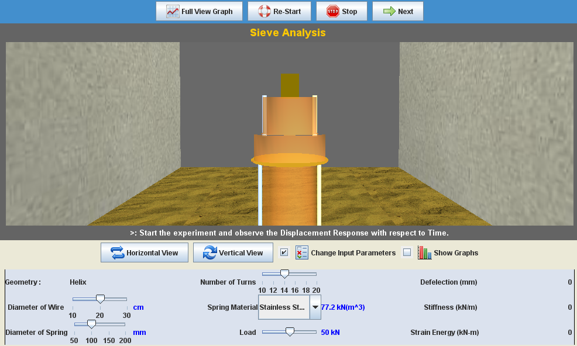
LABORATORY ROOM CONSISTS:
- Soil Profile
- Cutter
- Rammer
- Weight Balance

INPUT:
- Type of Soil

OUTPUT:
- Weight of Dried Soil
- Water content of the Soil
- Density of soil

